Stitch This!!!
135 Woodstream Point
Fayetteville, GA 30215

PROPOSAL

December 3, 2003

OmegaSat 1
312 Logan Street
Atlanta, GA 30312
ATTN: Ed Hampton


Augusta Lined Coach’s Jacket

Nylon taffeta outershell with 100% polyester brushed tricot lining, matching snap front, raglan sleeves, elastic cuffs, reinforced slash pockets, drawstring in bottom hem, water-resistant, machine washable.

Sizes: S-XXXL
Colors: Black, Gold, Navy, Orange, Red, Royal, Safety Green, Safety Orange
Price: S-XL (with embroidery) $23.00
XXL (with embroidery) $27.00
XXXL (with embroidery) $30.00

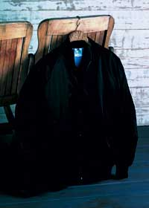
Augusta Satin Baseball Jacket with Stripe

Outer shell of nylon satin. Polyester brushed tricot lning. Baseball styling with raglan sleeves. Reinforced slash pockets. Matching 1x1 rib knit cuffs and bottom band with white stripes. Water-resistant and machine washable.

Sizes: S-XXXL
Colors: Navy, Red, Royal
Price: S-XL (with embroidery) $30.00
XXL (with embroidery) $34.00
XXXL (with embroidery) $36.50

Thank you,

Missy Lennon

